**PROTOCOL**to laboratory exercise

***Broad-Band-Amplifier***



|  |  |  |
| --- | --- | --- |
| Group / Class | Secretary | Signature |
| 5 / **4BHELS** | HOFSTÄTTER A. |  |
| Exercise- / Delivery date | Employee | Signature |
| 25. Nov. 2014  2. Dec. 2014 | HIRSCH L. |  |
| Teacher | Employee | Signature |
| Tillich | DÜRAUER J. |  |
| Grade | Employee | Signature |
|  |  |  |
| ***Transistor***  *2x BC546* | | |
| **Used Devices**   |  |  |  |  |  | | --- | --- | --- | --- | --- | | Nr. | Device | Manufactor | Type | Place Nr. | | 1. | Oscilloscope | Tektronix | TDS 1001B | - | | 2. | Function generator | Hameg | HM 8035 | - | | 3. | Power Supply | PS | 2403D | - |   **Used Programs**   |  |  |  | | --- | --- | --- | | Nr. | Name | Version | | 1. | Altium Designer | 13 | | 2. | Micro-Cap | 11 | | | |

ÜBUNGS-/ABGABE-DATUM

Klasse /Gruppe

NOTE

LEHRER

# Table of Contents

1 Table of Contents 2

2 Tasks 3

2.1 Given Values 3

3 Dimensioning 3

3.1 Calculation R3 3

3.2 Calculation R2 4

3.3 Calculation R1 4

3.4 Calculation C1 und C2 4

3.5 Calculation C3 4

3.6 Calculation C4 4

4 Measuring construction 5

5 Bias voltage 6

6 Output measurement 7

6.1 Dynamic Range 7

6.1.1 Measurement results (100mVpp) 8

6.1.2 Measurement results (200mVpp) 9

6.1.3 Measurement results (300mVpp) 10

7 Bode plot 11

7.1 Amplitude plot 11

7.2 Phase plot 11

8 Simulation 12

8.1 Simulation results 12

8.1.1 Transient analysis 12

8.1.2 Bode plot (Amplitude and Phase) 12

9 List of Figures 13

# Tasks

The aim of this lab exercise was to build a broadband amplifier. All values were calculated and the broadband amplifier were dimensioned in all his circumstances, at last and finally the hole circuit was implemented and built.

The following tasks were achieved and implemented.

1. Dimensioning
2. Measuring construction
3. Measuring of the bias voltage
4. Measuring of output voltage
5. Bode diagram (amplitudes and phase response)

## Given Values

The following Values were part of the individual tasks achievement and were taken firstly for dimensioning.

|  |  |  |  |  |
| --- | --- | --- | --- | --- |
| $$U_{b}=15V$$ | $$I_{c}=1mA$$ | $$V_{u}=30 dB$$ | $$R_{A}=10k$$ | $$B=β=300$$ |

# Dimensioning

For all following calculations the values from 2.1 Given Values were taken as reference.

The first assumption was that the voltage URE. The range of this voltage was 1-2 V.

Assumption: URE=2V

Based on this value the emitter resistor $R_{E}$ was calculated.

$$R_{E}=\frac{U_{RE}}{I_{C}}=\frac{2 V}{1 mA}=2 kΩ→R_{E2}=1k8 Ω$$

Afterwards the voltage UCE1 was chosen. The range for this voltage was 1-2.

Assumption: UCE1=2V

$$U_{RC}=U_{CE_{2}}=\frac{U_{b}-U_{RE}-U_{CE_{1}}}{2}=\frac{15 V-2 V-2 V}{2}=5.5 V$$

$$R_{C}=\frac{U_{RC}}{I_{C}}=\frac{5.5 V}{1mA}=5.5 kΩ →R_{C}=5k6 Ω$$

$$I_{B}=\frac{I_{C}}{B}=\frac{1mA}{300}=3.3 µA$$

Finally the current for the voltage divider was assumpted. The supposition for this current was 20 times bigger than I. From this it follows that: $I_{Q}=I_{B}*20=3.3 µA*20=66 µA$.

The so calculated value was a very important ingredient of the resistor calculation which set the bias voltage.

## Calculation R3

$$U_{BE}=0.7 V$$

$$U_{B1}=U_{RE}+U_{BE}=2.7 V$$

$$R_{3}=\frac{U_{B1} }{I_{Q}}=\frac{2,7 V}{66 µA} =40.91 kΩ→R_{3}=39 kΩ$$

## Calculation R2

$$U_{B2}=U_{B1}+U_{CE1}=4,7 V$$

$$R_{2}=\frac{U_{B2}-U_{B1} }{I_{Q}}=\frac{2 V}{66 µA}=30,303 kΩ→R_{2}=33 kΩ$$

## Calculation R1

$$R_{1}=\frac{U_{B}-U_{B2} }{I_{Q}}=\frac{15 V-4,7 V}{66 µA}=156,06 k→R_{1}=150 kΩ$$

$$r_{F}=\frac{U_{I}}{I_{C}}=\frac{26 mV}{1mA}=26 Ω$$

$$\left|V_{u}\right|=\left|\frac{\frac{1}{\frac{1}{R_{C}}+\frac{1}{R_{2}}} }{r_{F}+R_{E1}}\right|=\frac{3k5}{r_{F}+R_{E1}}=30= →{ R}_{E1}=\frac{3k5}{30}-26→R_{E1}=100 Ω$$

## Calculation C1 und C2

$$C_{1}=C_{2}=\frac{1}{2π*\left[R_{2}//R_{3}//β*(r_{F}+R_{E1})\right]}=\frac{1}{2π*\left[33k//39k//β*(26+39k)\right]}=131,14 nF$$

$$→C_{1}=C_{2}=100 nF$$

## Calculation C3

$$C_{3}=\frac{1}{2π*f_{g}*(R_{E2}//R_{E1})}=\frac{1}{2π*f_{g}*(1k8//100kΩ)}=16,8 µF→C_{3}=15 µF$$

## Calculation C4

$$C_{4}=\frac{1}{2π*f_{g}*(R_{A}+R_{C})}=\frac{1}{2π*100 Hz*(10k+5k6)}=102 nF→C_{4}=100 nF$$

# Measuring construction

Following cicuit shows the used measuring construction inclusive all dimensioned und calculated values.

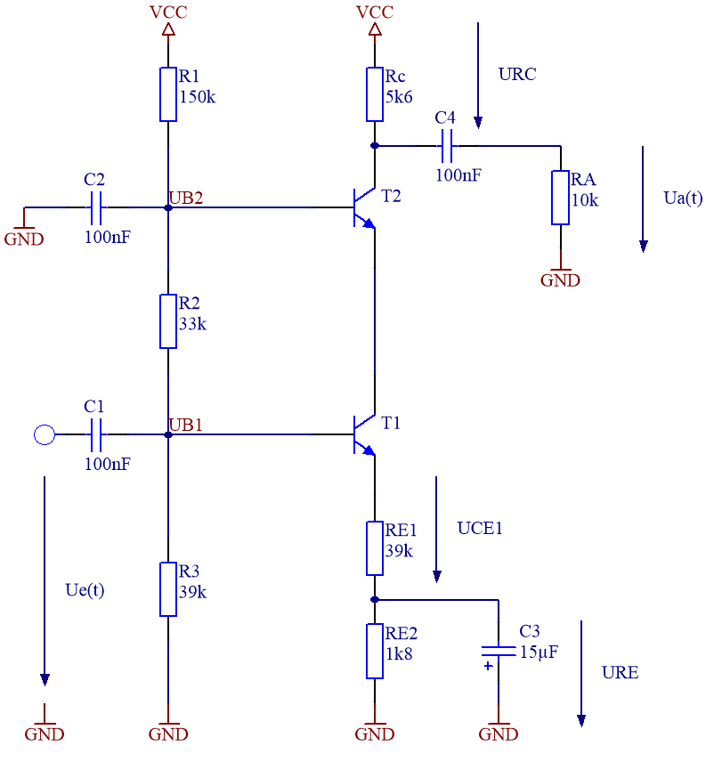

Figure 1. – Constructed measuring cicuit

# Bias voltage

The measurement of the bias voltage was made and compared with the calculated values.

The results of the measurement from the bias voltage were following.

|  |  |  |
| --- | --- | --- |
|  | Measured [V] | Calculated [V] |
| UB1 | 2,56 | 2,7 |
| UB2 | 4,60 | 4,7 |
| URC | 5,80 | 5,5 |
| UCE1 | 2,10 | 2,0 |
| UCE2 | 5,05 | 5,5 |
| URE | 1,80 | 2,0 |

And additional measurement of the potentials UB1 and UB2 should exhibit in which range compared to the supply voltage the voltages were located.

On the measurement picture a GND and Vcc Line were drawn.



GND

Vcc

Figure 2. – Compare measurements

# Output measurement

A sinus with a frequency of 1kHz and an amplitude of 100mVpp was supplied on the input pun of the broad-band-amplifier. The following picture shows the input signal (Ue – Ch2) and the output signal (Ua – Ch1).

Based on this picture the gain could be read and also seen that the amplifier inverts the output signal.

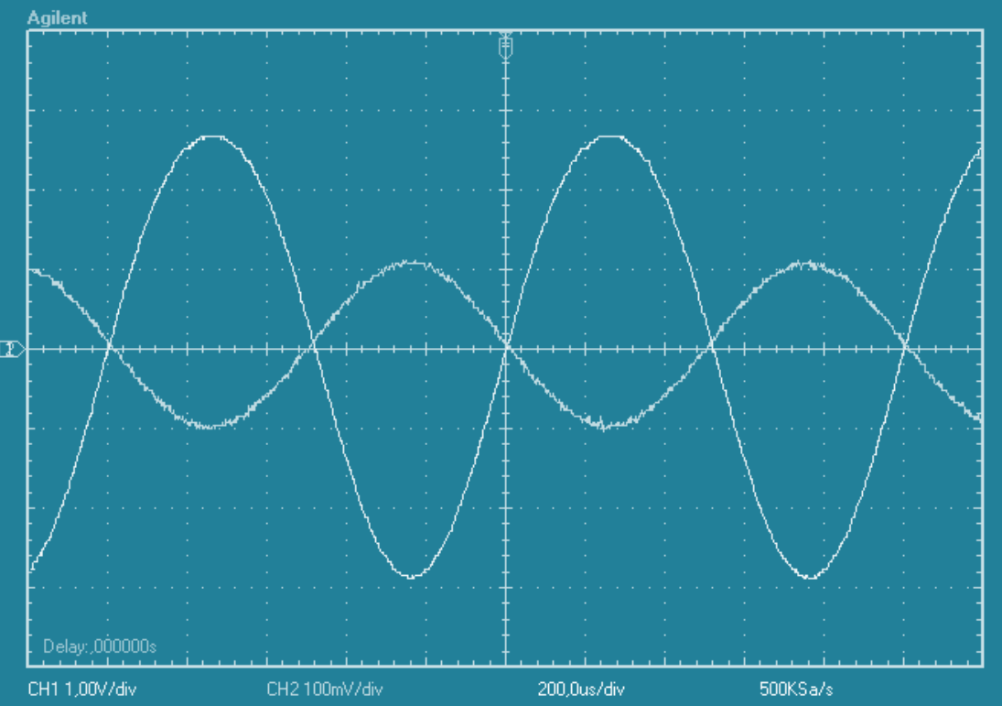

Figure 3. – Input signal with 100 mVpp and 1 kHz

## Dynamic Range

The following measurements showed the dynamic range of the amplifier.

By all following three signals an input signal of 1 kHz was used. The amplitude varies from 100mVpp to 300 mVpp.

Based on the following measurements it was recognizable that the amplifier works probably in the range of 1-100mVpp without saturation.

With the measured values the gain could be recalculated.

$$V_{u}=-\frac{U_{A}}{U_{E}}=-\frac{2,7 V}{0,1 V}=-27 dB≅28,6 dB$$

### Measurement results (100mVpp)

The first measurement was executed with an input signal with an amplitude from 100mVp.

The Signal is not much damped and available in it´s origin form.



GND

Figure 4. – Dynamic range (100mVpp)

### Measurement results (200mVpp)

The first measurement was executed with an input signal with an amplitude from 200mVp.

The output signal is already not very symmetric and a little bit cut off.



GND

Figure 5. – Dynamic range (200mVpp)

### Measurement results (300mVpp)

The first measurement was executed with an input signal with an amplitude from 300mVp.

In this measurement the amplifier is already in a heavy saturation.



GND

Figure 6. – Dynamic range (300mVpp)

# Bode plot

## Amplitude plot

Figure 7. – Measured Amplitude Response

## Phase plot

Figure 8. – Measured Phase Response

# Simulation

To consolidate the measured and calculated circuit the whole circuit was in addition to the built up simulated in Micro-Cap.

## Simulation results

### Transient analysis

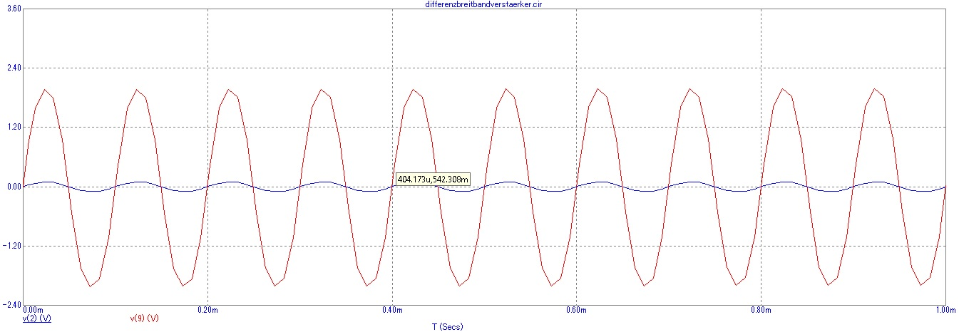

Figure 9. – Simulation of the Transient analysis with Micro-Cap

### Bode plot (Amplitude and Phase)

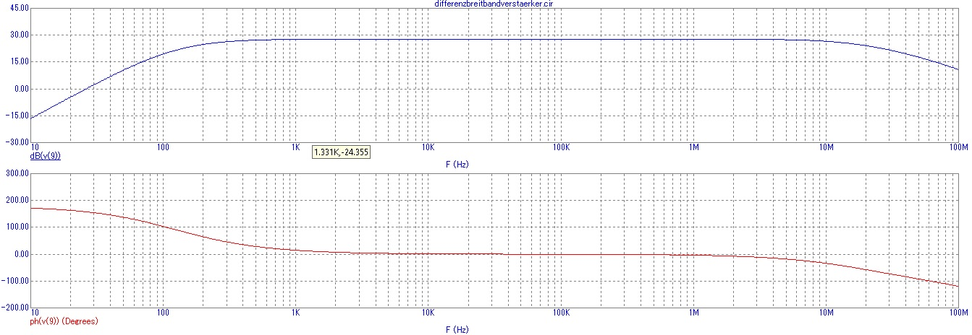

Figure 10. – Simulation of the bode plot with Micro-Cap

# List of Figures

Figure 1. – Constructed measuring cicuit 5

Figure 2. – Compare measurements 6

Figure 3. – Input signal with 100 mVpp and 1 kHz 7

Figure 4. – Dynamic range (100mVpp) 8

Figure 5. – Dynamic range (200mVpp) 9

Figure 6. – Dynamic range (300mVpp) 10

Figure 7. – Measured Amplitude Response 11

Figure 8. – Measured Phase Response 11

Figure 9. – Simulation of the Transient analysis with Micro-Cap 12

Figure 10. – Simulation of the bode plot with Micro-Cap 12